董事會決議案

Board Resolution
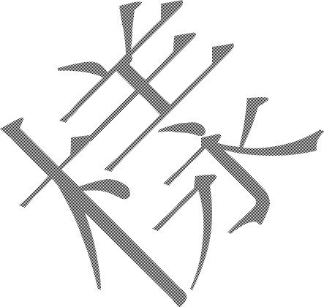
公司名稱： | (「本公司」)
Client Name: | (the “Company”)
本公司董事會於 | (日期)
Minutes of a Meeting of the Board of Directors of the Company held on | (Date)
在
At | 擧行的董事會會議記錄。
會議主席:
Chairman of the meeting:
出席人(出席董事全名):
Present (Full Name of Directors present):

通知書及法定人數:

Notice and Quorum:

有關通知已按要求發出，且與會人數符合法定人數要求，主席宣佈會議有效。

The requisite notices having been given and a quorum being present, the Chairman declared the meeting duly and validly constituted.

- 獲授權人士

Authorized Person

茲決議本公司將於昊天國際證券有限公司開立證券交易(現金／保證金) 及／或 股票期權交易帳戶，並授權下列人士作為獲授權人可代表申請人操作帳戶及可按客戶協議作出任何其他事宜（包括（i）簽署、簽訂及交付與帳戶相關之所有協議或文件及（ii）簽發指令為證券／期貨進行支付、提取及／或轉帳事宜。）

It was resolved that with immediate effect, a securities trading (Cash/margin) and or Stock Options trading account account(s) be opened with Hao Tian International Securities Limited and that the following person(s) is / are appointed as authorized person(s) of the Company to (i) sign, execute and deliver all agreements and documents in relations to the account(s); and (ii) to sign and/or effect payment, withdrawal and/or transfer transaction(s) for securities/futures.

姓名 | 稱號 / 職銜 | 香港身份證／護照號碼 | 簽署式樣
Name | Title / Position | HKID Card / Passport No. | Specimen Signature

(2)

(3)

(4)

(5)

- 獲授權交易人士

Authorized Trading Person

茲決議本公司授權下列人士作為獲授權人可代表申請人可簽署及／或進行證券及／或期貨交易。

It was resolved that with immediate effect, the following authorized person(s) is / are appointed as authorized trading person(s) and authorized to sign and/or effect securities and/or futures transaction(s).

姓名 | 稱號／職銜 | 香港身份證／護照號碼 | 簽署式樣
Name | Title / Position | HKID Card/ Passport No. | Specimen Signature

(2)

(3)

(4)

(5)

1

- 商務私章式樣（如適用）
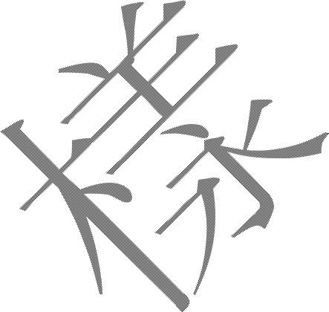
Company Chop Specimen (If Applicable)

印章或印鑑式樣

Specimen Chop or Seal

會議結束

Close of Meeting

由於沒有其他事項，主席宣布會議結束。

There being no further business, the Chairman declared the meeting closed.

主席簽署:

SIGNED by Chairman:

主席

Chairman

2

